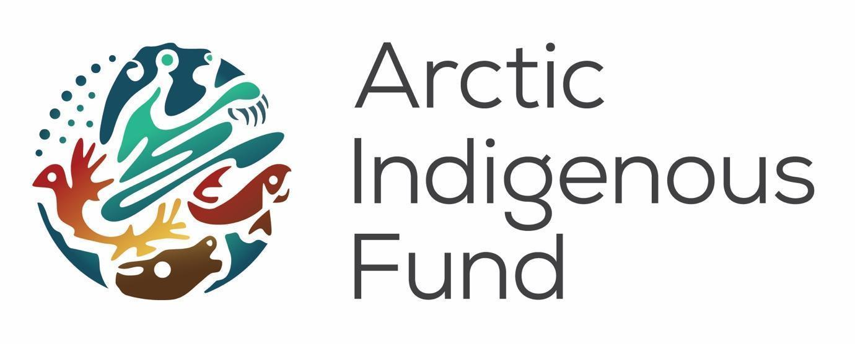

Hello! The Alaska arm of Arctic Indigenous Fund invites you and your organization to complete this proposal.

Our Vision
Our vision is for thriving Indigenous communities in the Arctic. We support that vision by doing grantmaking work in the Arctic that is guided by our cultural values:
- Acknowledging our communities to make decisions for themselves on their own terms;
- Helping one another, because we are stronger together;
- Embracing the healing power of lands and waters;
- Treating each other and our partners with respect, patience, and kindness;
- Carrying out our responsibilities in a manner that is flexible, knowledgeable, transparent, accountable, and inclusive; and
- Contributing to the strength of our communities, while maintaining a spirit of humility, humour, and generosity.

Indigenous-led philanthropy in the Arctic that is rooted in Indigenous cultures, traditions, and self-identified goals for the future.

Criteria
Indigenous Youth organizations or initiatives.

Check-List:
- Complete form
- Email form to: alaska@arcticindigenousfund.com
- Proposal deadline: December 30, 2020

Cycle 2 Proposal Application
Name of Youth Organization/Individual
Key Contact Person Name
Title/Role at Organization
Contact Email
Contact Phone
Organization Mailing Address
Grant Agreement Signatory Name and Email Contact
Tell us about your organization and what you do in two sentences
Website link:
Youth Project/Program Title
Community
Region/Territory/Province/State
Country
Is the project indigenous-led?
Indigenous Peoples Involved
AIF Advisor Contact
Total Project/Program Budget (USD)
Amount Requested from AIF (USD)
Does your organization have a bank account that can receive funding in USD?
Date (dd-mm-yy)
Project Start and End Date
(dd-mm-yy) to (dd-mm-yy)
Please write in 500 words or less how you propose to use this funding, what you hope to accomplish, and how your project contributes to thriving Arctic Indigenous communities. Optional: You may submit audio or video or visual to accompany this written portion if you’d like.

Grant Budget Form
Please provide a breakdown of how you intend to spend the funding amount requested from the Arctic Indigenous Fund.

Amount Requested (USD): ______________________*
Category | Projected Expenses (USD) | Additional Notes:
Example 1
Example 2
Total
*Please keep in mind the following guidelines and requirements as you complete your proposal:
- The Arctic Indigenous Fund discourages proposals that include hospitality for the provision of drugs or alcohol as a budget item.
- If you receive a grant and your plans change significantly from the original proposal, please contact your regional advisor to discuss. Changes to your original budget greater than $4000 will require you to submit an updated budget form and it may be necessary to send a revised grant agreement.

Other Sources of Funding Requested/Confirmed for this Project/Program
Organization | Requested (USD) | Confirmed (USD)
Organization
Organization 2
Additional Information

Timelines

- December 30, 2020: Interest due
- January, 2021: Advisor review
- February, 2021: Award notice
Our Leadership

The Arctic Indigenous Fund makes space for young Indigenous leaders across the Arctic to have full authority over philanthropic resources being directed into their communities. Arctic Indigenous Fund Advisors make decisions about the funding priorities, partners, application and reporting process, and grant allocations.

Regional Advisors:
- Chandre Szafran - Alaska
- Christina Henriksen - Sápmi
- Dewey Kk’ołeyo Putyuk Hoffman - Alaska
- Jana Angulalik - Canada
- Kuluk Lyberth - Greenland
- Marion Aslaksen Ravna - Sápmi
- Tukumminngiaq Olsen - Greenland
- Shayla Snowshoe - Canada

Our Partners

The Arctic Indigenous Fund is administered and managed by the staff of the Arctic Funders Collaborative (AFC), a network of philanthropic funders collaborating to support more effective and responsible grantmaking across the Arctic. The Arctic Funders Collaborative staff is based in Yellowknife, Northwest Territories, Canada, and is a part of the Tides Canada Initiatives organization.

RSF Social Finance in the United States is one of our key partners and administers the Arctic Indigenous Fund grants on our behalf. Throughout the application process, you may be contacted by staff at the Arctic Funders Collaborative or RSF Social Finance to provide information or documentation required by RSF Social Finance to administer grants. If your proposal is approved, you will be required to sign a grant agreement with RSF Social Finance to receive funding from the Arctic Indigenous Fund. You may contact your Regional Advisor or the AFC staff, if you have any questions about information requests, process, communications, and contacts.

The Arctic Indigenous Fund is generously supported with funding from the Tamalpais Trust, NoVo Foundation and JW McConnell Foundation.

Mársı Thank you
Hąį’ Quana
ᖁᔭᓐᓇᒦᒃ (Qujannamiik) Quyanainni
Máhsi
Máhsı Mahsı̀

Giitu! Gæjhtoe! Giituo

Qujanaq Quyanaqpak

Quyaana Baasee’

